SSD TESTS
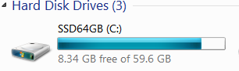
Crucial m4 SSD 64GB Soft Ver.010G
2013-04-01 at 11:00 pm
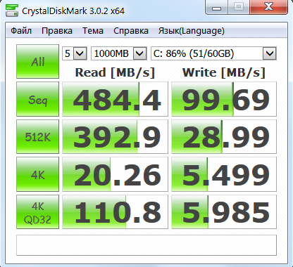

2013-04-01 at 11:10 pm
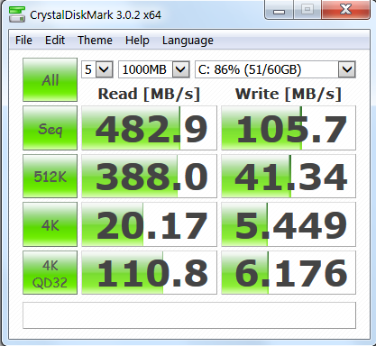

-----------------------------------------------------------------------
CrystalDiskMark 3.0.2 x64 (C) 2007-2013 hiyohiyo
Crystal Dew World : http://crystalmark.info/
-----------------------------------------------------------------------
* MB/s = 1,000,000 byte/s [SATA/300 = 300,000,000 byte/s]

Sequential Read : 482.918 MB/s
Sequential Write : 105.682 MB/s
Random Read 512KB : 387.973 MB/s
Random Write 512KB : 41.337 MB/s
Random Read 4KB (QD=1) : 20.170 MB/s [ 4924.3 IOPS]
Random Write 4KB (QD=1) : 5.449 MB/s [ 1330.2 IOPS]
Random Read 4KB (QD=32) : 110.846 MB/s [ 27062.1 IOPS]
Random Write 4KB (QD=32) : 6.176 MB/s [ 1507.8 IOPS]

Test : 1000 MB [C: 86.0% (51.3/59.6 GB)] (x5)
Date : 2013/04/01 23:20:49
OS : Windows 7 Home Premium Edition SP1 [6.1 Build 7601] (x64)

Crucial m4 SSD 64GB Soft Ver.040H
2013-04-01 at 11:50 pm
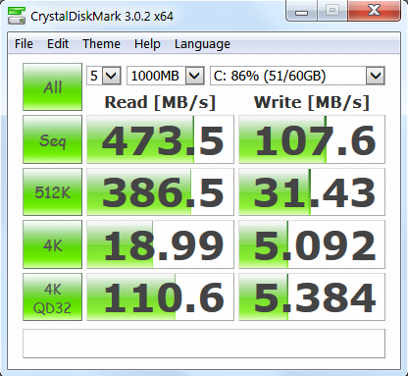

RAID1 2 x Hitachi 2000GB
2013-04-02 at 00:010 am

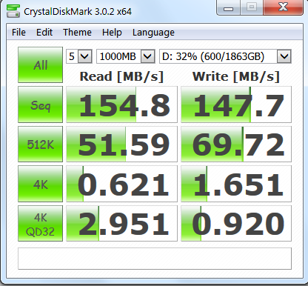

eSATA WD 2000GB
2013-04-02 at 00:20 am

